- Write a single ansible playbook which will install apache and nginx. Note: Playbook should not be hardcoded and pass the variables from different file.

Objective
To create and execute a single Ansible playbook that installs Apache and Nginx on target servers without hardcoding values, by passing package names and configuration values from an external variables file.

Prerequisites

- Linux servers (Debian/Ubuntu based)
- Ansible installed on control node
- SSH access to target nodes
- Inventory file configured
- Root or sudo privileges on target machines

Steps Performed:

Step 1: Created a Variable File (vars.yml)
- Defined all configurable values in a separate file to avoid hardcoding.
- Stored web server package names and Nginx port number.
Variables defined:
---
apache_package: apache2
nginx_package: nginx

apache_port: 81
nginx_port: 82



Step 2: Created a Single Ansible Playbook
- Created install_webservers.yml.
- Enabled privilege escalation using become: yes.
- Included the variable file using vars_files.
Playbook content :
---
- name: Install and Configure Apache and Nginx
hosts: webservers
become: yes
vars_files:
- vars.yml

tasks:

- name: Update apt cache
apt:
update_cache: yes

- name: Install Apache
apt:
name: "{{ apache_package }}"
state: present

- name: Install Nginx
apt:
name: "{{ nginx_package }}"
state: present

- name: Change Apache port
lineinfile:
path: /etc/apache2/ports.conf
regexp: '^Listen'
line: "Listen {{ apache_port }}"
notify: Restart Apache

- name: Change Apache VirtualHost port
replace:
path: /etc/apache2/sites-available/000-default.conf
regexp: '<VirtualHost \*:80>'
replace: '<VirtualHost *:{{ apache_port }}>'
notify: Restart Apache

- name: Change Nginx port
lineinfile:
path: /etc/nginx/sites-available/default
regexp: 'listen 80 default_server;'
line: " listen {{ nginx_port }} default_server;"
notify: Restart Nginx

- name: Change Nginx IPv6 port
lineinfile:
path: /etc/nginx/sites-available/default
regexp: 'listen \[::\]:80 default_server;'
line: " listen [::]:{{ nginx_port }} default_server;"
notify: Restart Nginx

handlers:

- name: Restart Apache
service:
name: "{{ apache_package }}"
state: restarted

- name: Restart Nginx
service:
name: "{{ nginx_package }}"
state: restarted

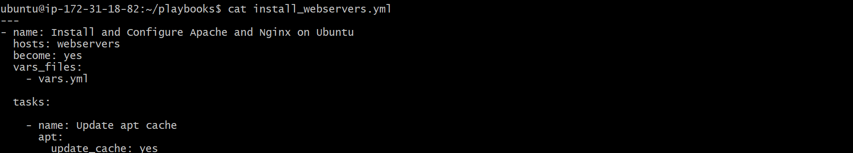

Step 3: Executed the Playbook
- Performed syntax validation using:
- ansible-playbook install_webservers.yml --syntax-check
- Executed the playbook successfully:
- ansible-playbook install_webservers.yml

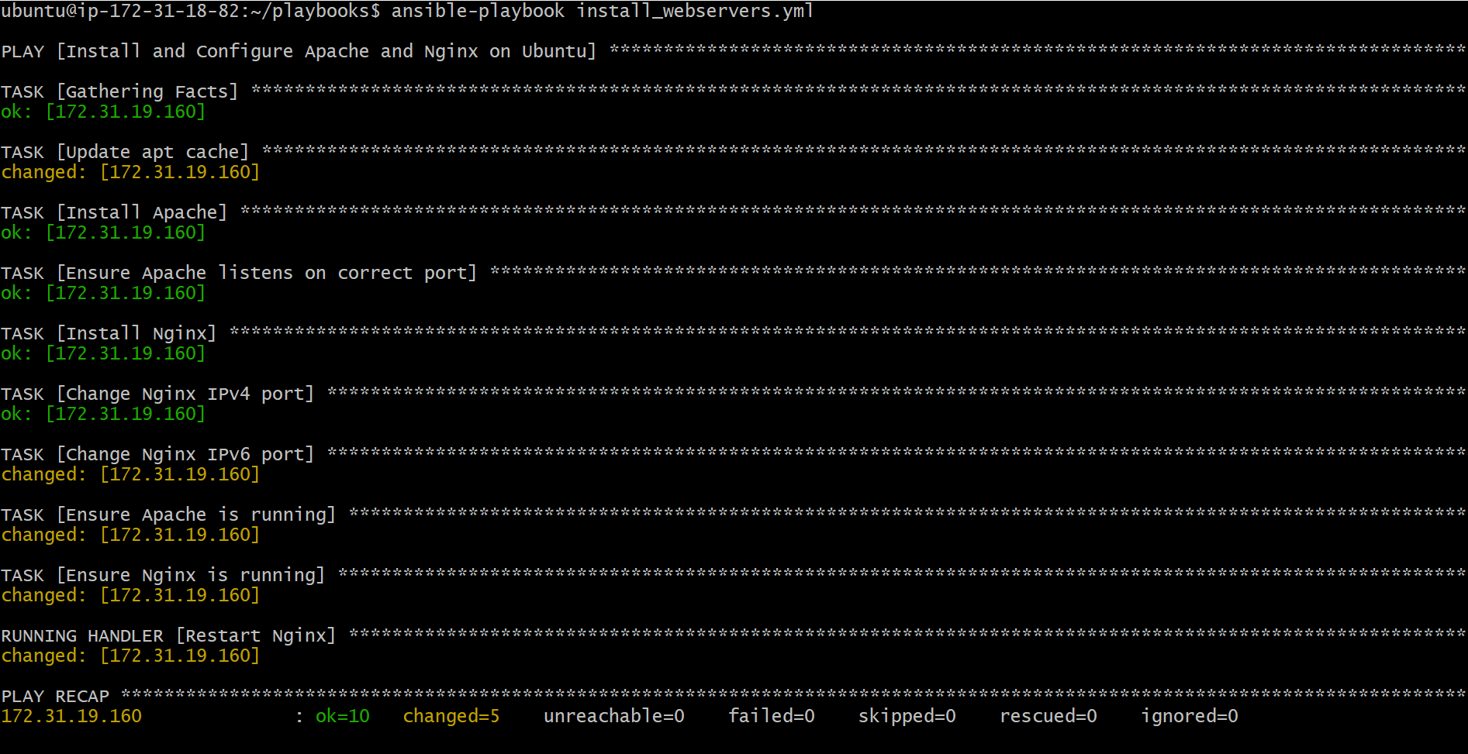

Step 4: Verification
- Verified Apache running on port 81 via browser.
- Verified Nginx running on port 82 via browser.
- Play recap showed no failures.
Validation Steps
- Access Apache:
- http://<server-ip>
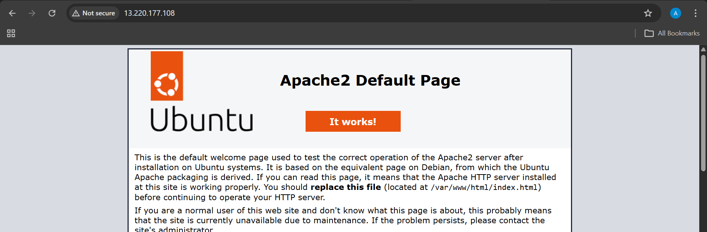
- Access Nginx:
- http://<server-ip>:81
- Confirm services:
- systemctl status apache2

- Ansible playbook to create 10 different directories with minimal code and directory names should be passed as variables.

Objective
To create 10 different directories on multiple target nodes using a single Ansible playbook, with directory paths passed through a variable file, keeping the playbook minimal and reusable.
Prerequisites
- Ansible installed on control node
- Inventory configured with target hosts
- SSH connectivity to managed nodes
- Root/sudo access (become: yes)
- Linux target systems
Steps Performed:

Step 1: Created Variable File (vars.yml)
- Defined directory paths as a list variable.
- Avoided hardcoding paths in the playbook.
Directories defined:
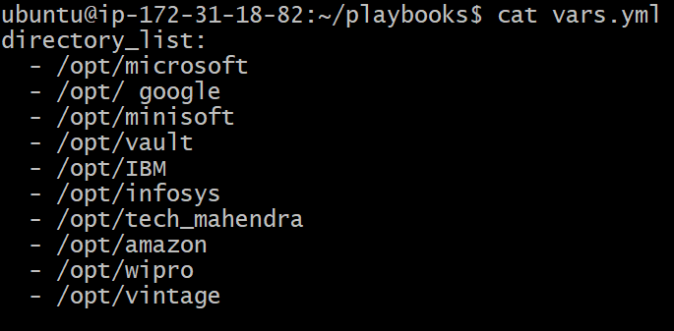

Step 2: Created a Single Ansible Playbook
- Created create_multiple_dir.yml.
- Enabled privilege escalation using become: yes.
- Included variables using vars_files.

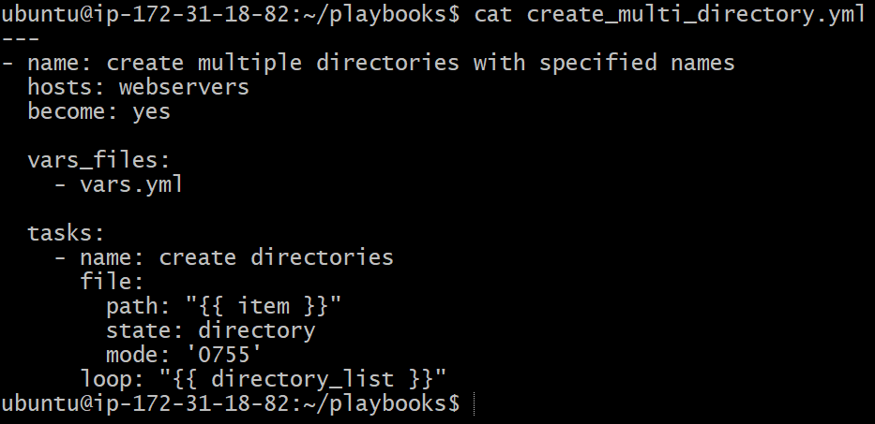

- Used the file module to create directories.
- Used a single task with a loop to iterate over directory list.
- Set directory permissions using mode: 0755.
Step 3: Executed the Playbook
- Ran the playbook using:
- ansible-playbook create_multiple_dir.yml
- Play executed successfully on all target nodes.
- No failures or unreachable hosts reported.

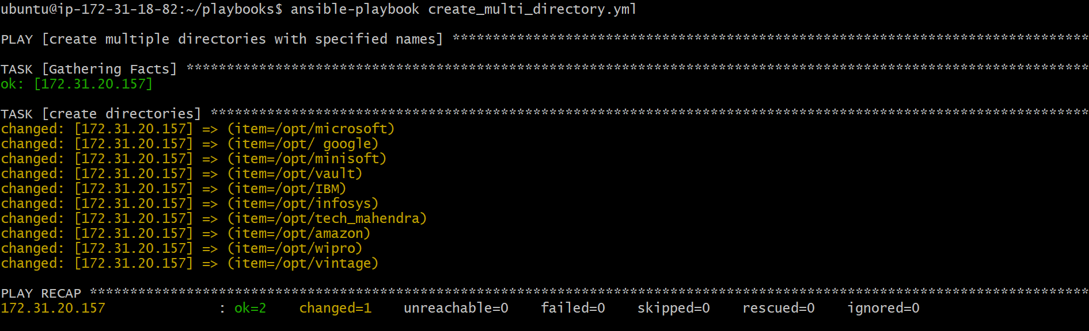

Step 5: Verified Directory Creation
- Logged into each target node.
- Navigated to /opt directory.
- Verified all 10 directories were created:
  - dir1 through dir10
- Confirmed correct permissions and ownership.
Validation Steps
On each managed node:
cd /opt
ls


- Ansible playbook to copy ssh-keygen from master to worker nodes. Note: a)Provision new 3 ec2 machines, one master and two worker nodes. b)Create common user called ansadm and provide sudo priviliges on 3 ec2 instances. c)Create ssh-keygen in master and your playbook should copy the keygen making it password less authentication.

Objective
To provision a master and worker setup where a common user (ansadm) is created on all nodes, SSH keys are generated on the master node, and passwordless SSH access is enabled from the master to all worker nodes using Ansible.
Prerequisites
- Ansible installed on control node
- AWS EC2 instances provisioned (1 Master, 2 Workers)
- Inventory file configured with master and workers groups
- SSH access to EC2 instances using a PEM key (sshless.pem)
- Ubuntu OS on all nodes
Steps Performed:
Step 1: Provisioned EC2 Instances
- Launched three EC2 instances from the AWS EC2 console.
- Assigned instance roles as:
  - 1 Master node
  - 2 Worker nodes
- Used Ubuntu AMI and t3.micro instance type.
- Verified all instances were in Running state with 3/3 status checks passed.
- Confirmed instance naming:
  - master
  - worker-01
  - worker-02

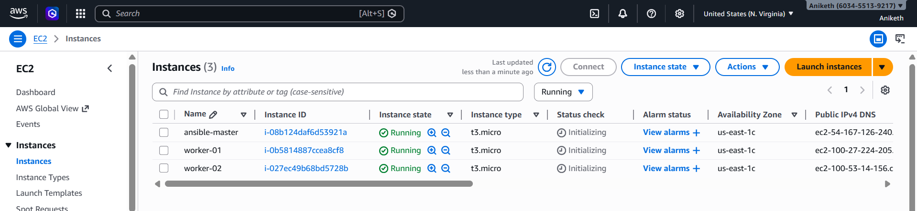

Step 2: Ansible inventory and configurations
On Ansible master :
Install ansible {apt update , apt install ansible}
Check python version
Create ansible.cfg and hosts (add private ips of worker nodes) at /etc/ansible:

mkdir -p /etc/ansible
vi /etc/ansible/ansible.cfg

[defaults]
remote_user = root
host_key_checking = false
forks = 10

vi /etc/ansible/hosts .
From control node:
Create ssh-keygen , copy the keygen created .

Worker node 1:
Paste the copied key in
/.ssh/authrized_keys

Worker node 2:
Paste the copied key in
/.ssh/authrized_keys

Test:
From control node:
ansible all -m ping

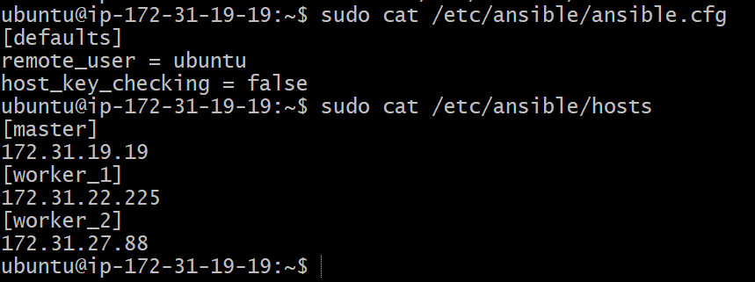

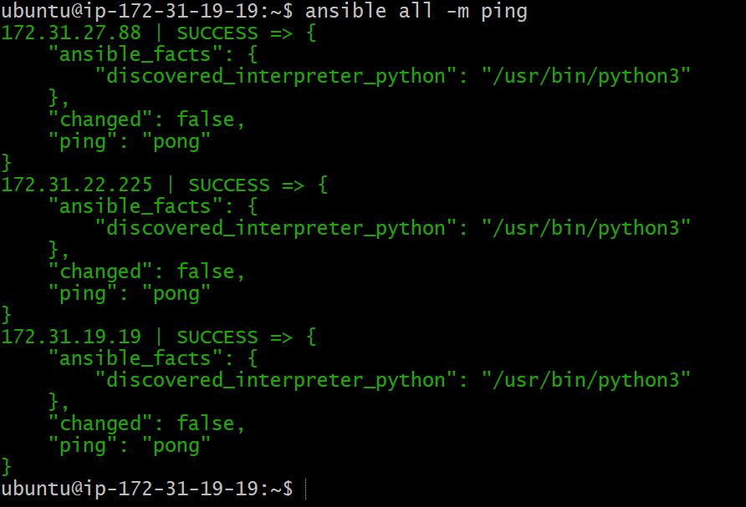

Step 3: Created Common User on All Nodes
- Created an Ansible playbook to create a common user ansadm.
- Assigned /bin/bash as default shell.
- Added user to sudo group.
- Enabled passwordless sudo using /etc/sudoers.d/ansadm.
- Executed playbook on all nodes using Ansible.

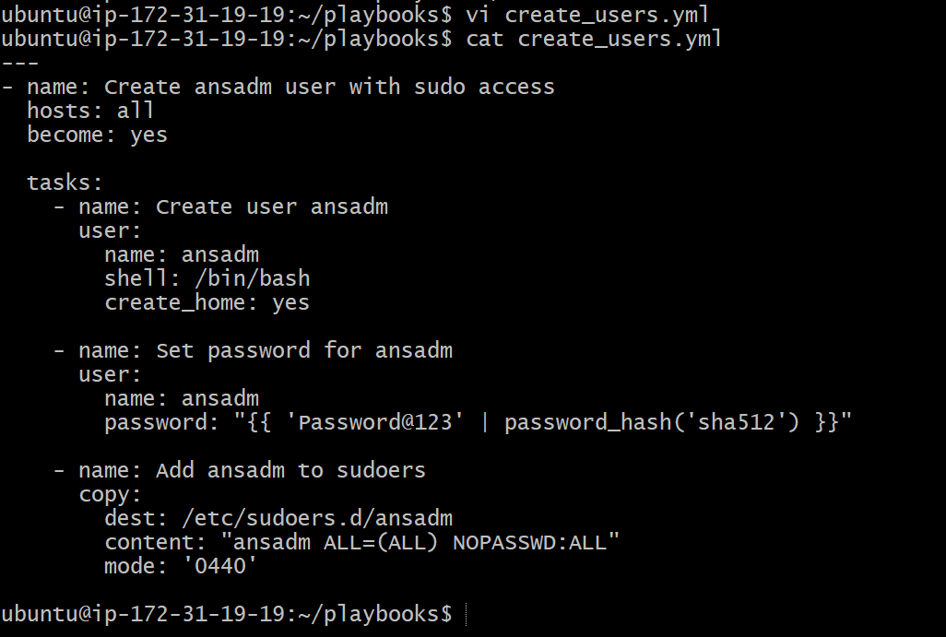

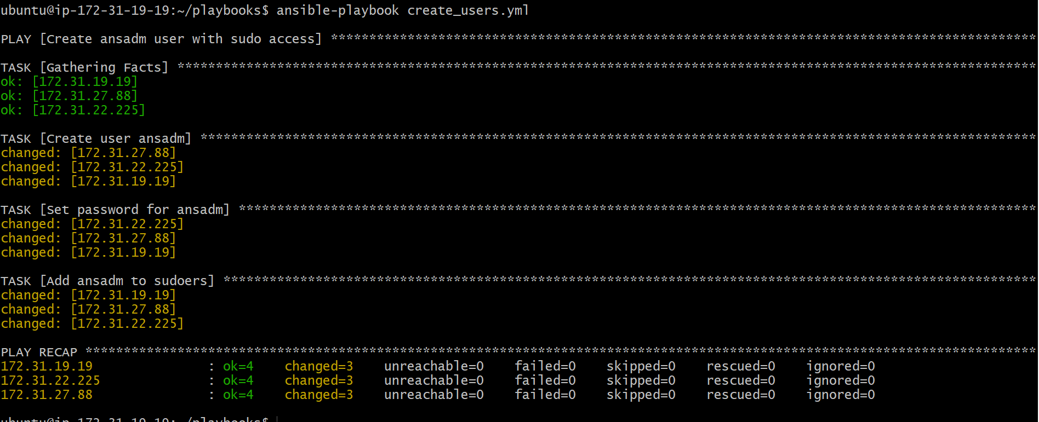

Step 4: Verified User Creation
- Logged into each instance.
- Verified ansadm user exists.
- Confirmed passwordless sudo access using:
- sudo su - ansadm
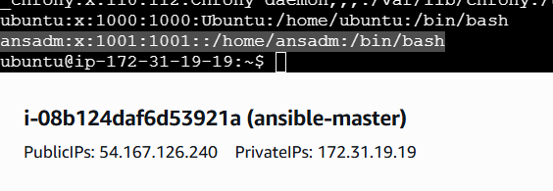
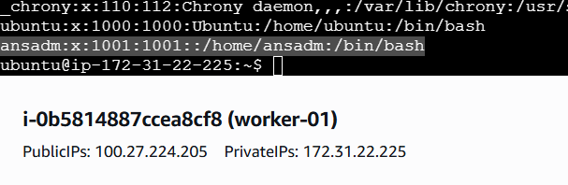

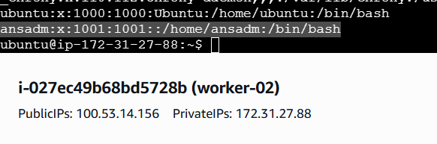

Step 5: Generated SSH Key on Master Node
- Created a dedicated Ansible playbook for SSH key setup.
- On the master node:
  - Created /home/ansadm/.ssh directory.
  - Set correct ownership and permissions.
  - Generated SSH key pair (id_rsa and id_rsa.pub) as ansadm.
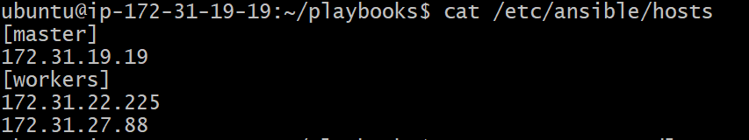

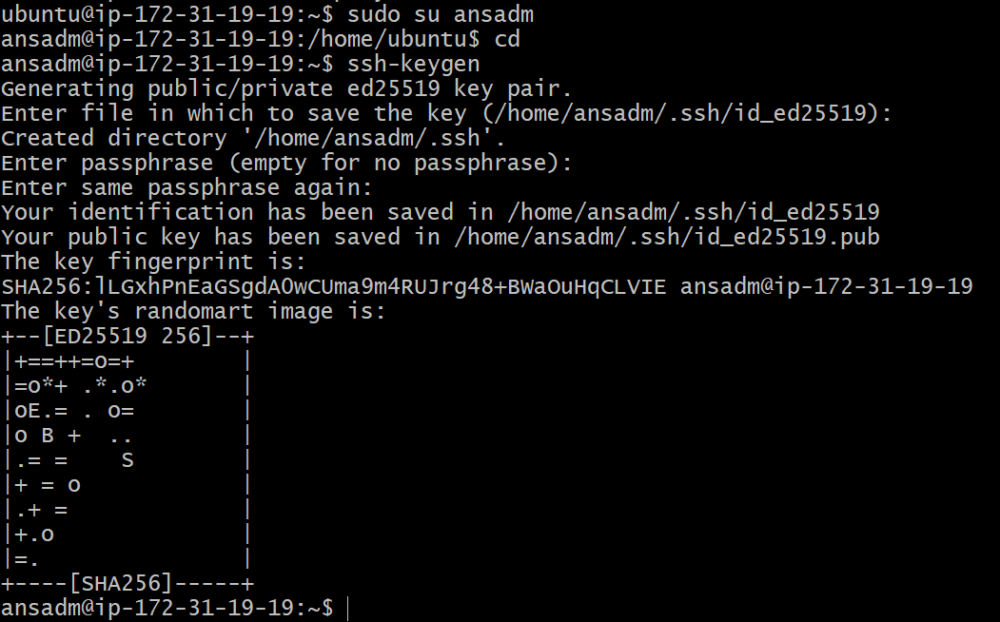

Step 6: Read Master Public Key
- Used Ansible slurp module to read the master’s public key.
- Stored the key content in a registered variable.
Step 7: Copied SSH Key to Worker Nodes
- Added the master’s public key to authorized_keys on all worker nodes.
- Used authorized_key module.
- Ensured correct decoding using b64decode.
- Maintained proper ownership and permissions.

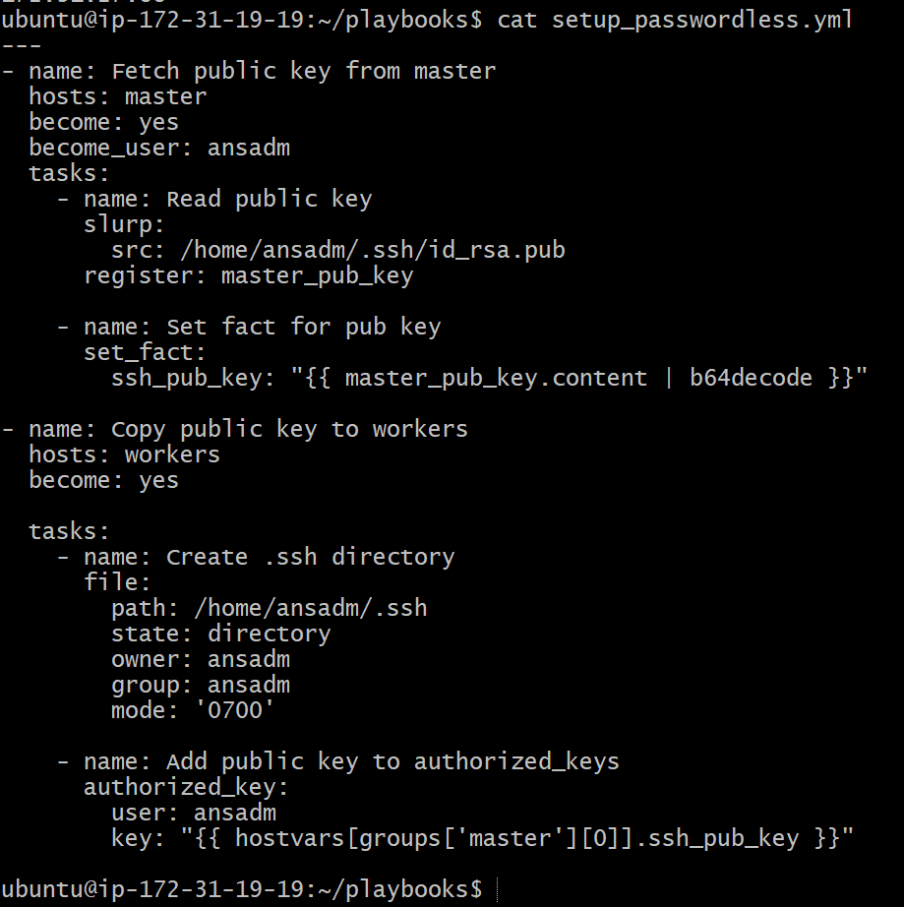

Step 8: Executed SSH Key Distribution Playbook
- Ran the SSH key playbook using Ansible.
- Verified successful execution on both master and worker nodes.
- 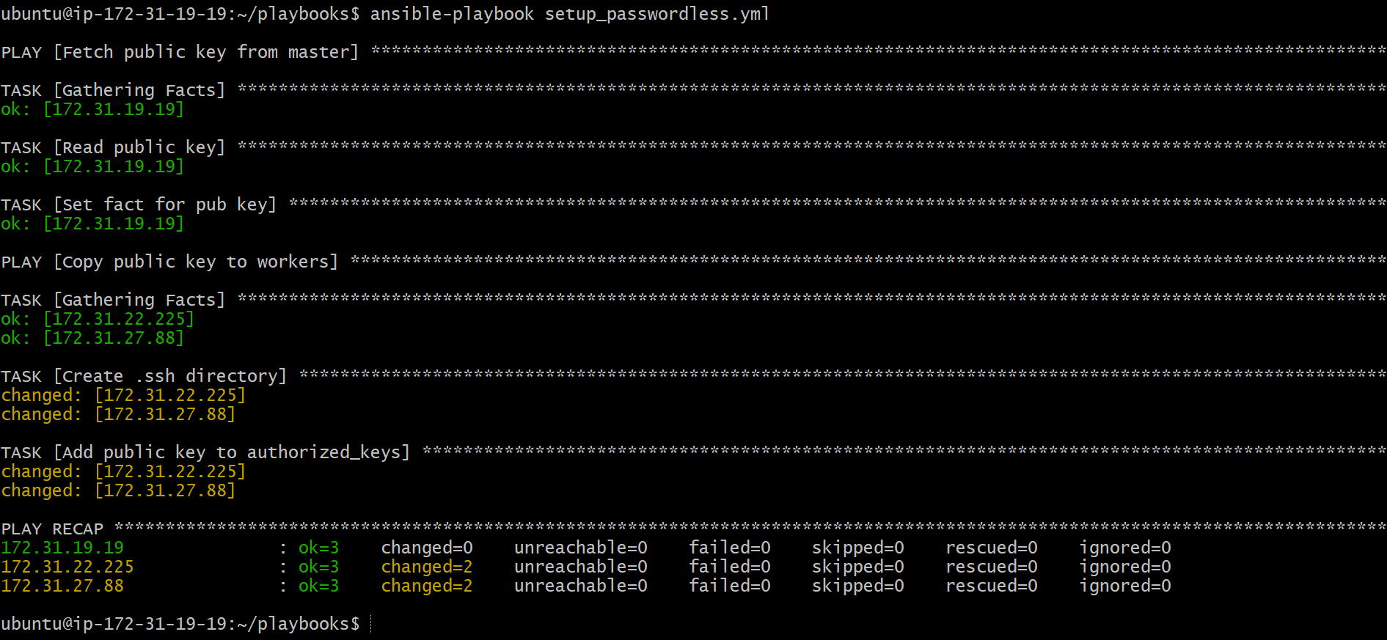
Step 9: Verified Passwordless SSH Authentication
- Logged into the master node as ansadm.
- Initiated SSH connection to worker nodes:
- ssh ansadm@<worker-ip>
- Confirmed login without password prompt.

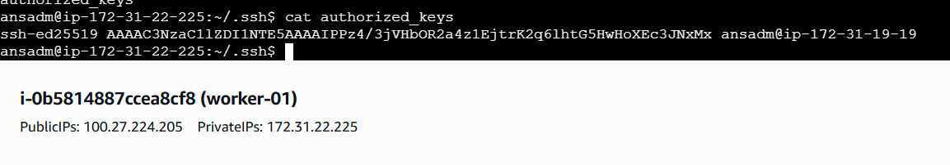

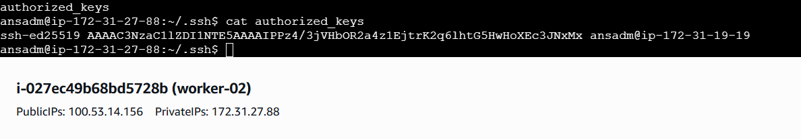

- Ansible playbook to inject ansible vault variables.

Objective
To securely store sensitive variables using Ansible Vault and inject those encrypted variables into an Ansible playbook at runtime.
Prerequisites
- Ansible installed on control node
- Access to target hosts
- Basic knowledge of YAML
- Vault password available
- Inventory file configured
Steps Performed:
Step 1: Created a Plain Variables File
- Created a file named password.yml.
- Added sensitive variables in plain text for initial setup.
Variables added:
- db_user
- db_password
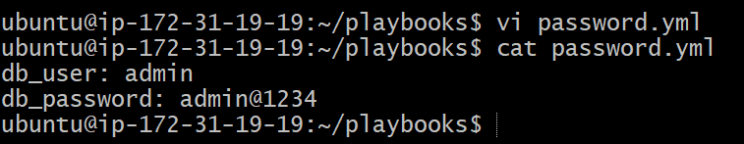

Step 2: Encrypted the Variables File Using Ansible Vault
- Used Ansible Vault to encrypt password.yml.
- Set and confirmed a vault password during encryption.
Command used:
ansible-vault encrypt password.yml

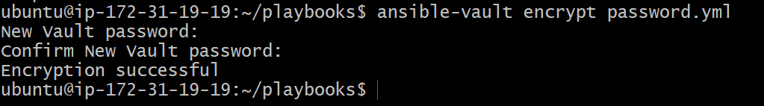

Step 3: Verified Vault Encryption
- Displayed the encrypted file to confirm it is no longer readable.
- Used Ansible Vault view command to verify encrypted content.
Commands used:
cat password.yml
ansible-vault view password.yml

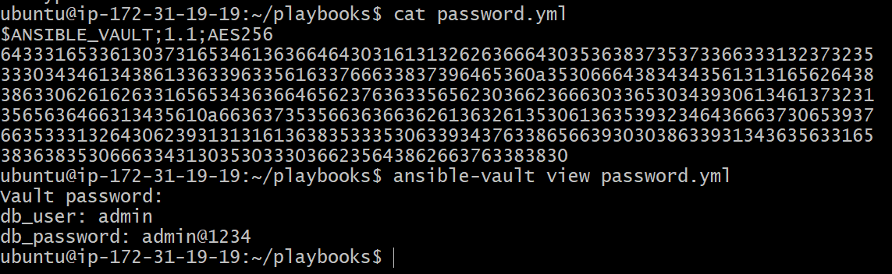

Step 4: Created Ansible Playbook to Inject Vault Variables
- Created playbook use_vault.yml.
- Included encrypted variables file using vars_files.
- Used the variables inside a task to confirm injection.

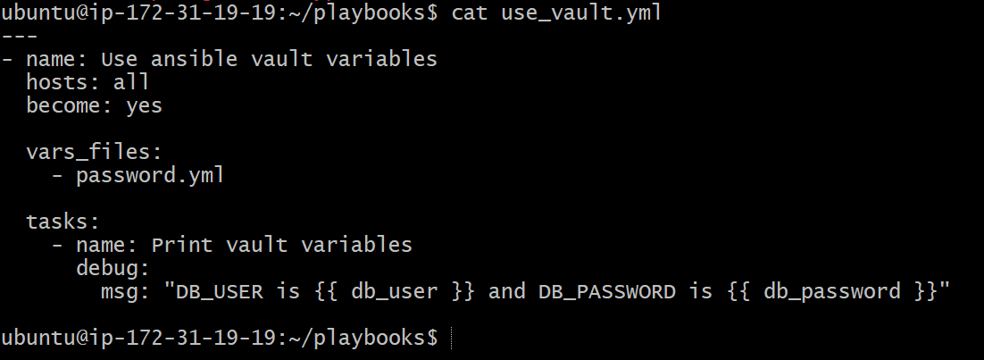

Step 5: Executed the Playbook with Vault Password
- Ran the playbook and provided vault password at runtime.
- Ansible successfully decrypted the variables.
Command used:
ansible-playbook use_vault.yml --ask-vault-pass

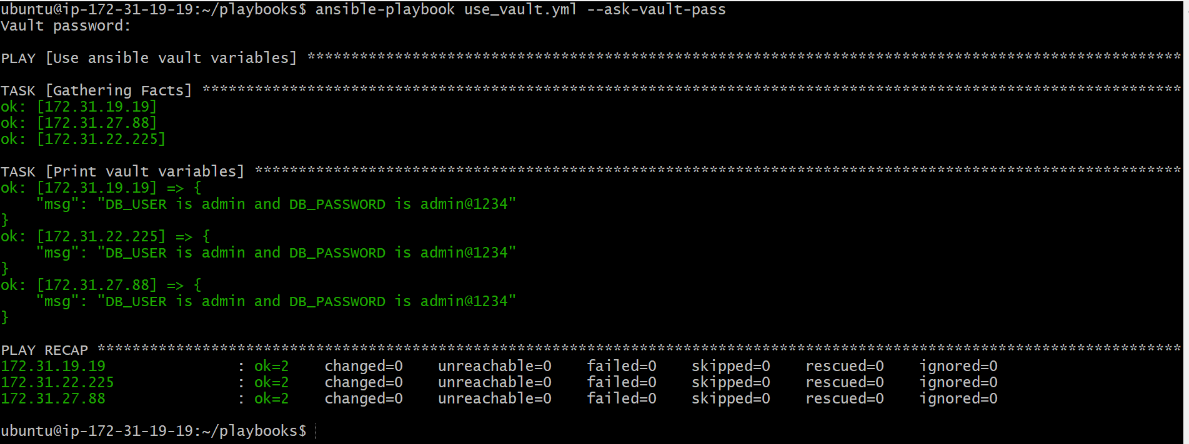

Step 6: Verified Output
- Playbook executed successfully on all target nodes.
- Vault variables were correctly injected and accessed.
- No failures reported in play recap.
Validation Steps
- Vault variables displayed correctly in output.
- Play recap showed:
  - failed=0
  - unreachable=0

